### Current Activities

Our [029 card punch](http://slx-online.biz/hursley/hardware-data-detail.asp?id1=937) has been fitted with a wooden leg. One of the back legs was damaged in transit from Oslo, and the initial fix proved to be too unstable. We are now looking for a parrot to sit on top.

The four punch & verifier machines on display now sit on appliance moving rollers that were surplus to requirements after my own home garage reorganisation. This means they can be easily pulled forward away from walls for access to the rear. The first practical use has been the 029, now that it is stable. It has received a full preventive maintenance; mechanically it appears to be sound apart from one of the two drive belts that has stretched. Unfortunately we don’t have a spare but we might be OK for a while. There are still faults in the relay circuitry somewhere; fortunately we have found a wiring diagram on line and tracing continues!

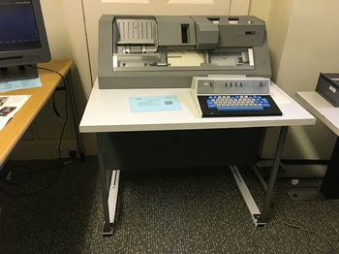 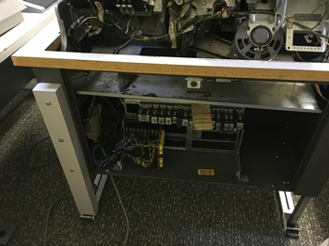

An artefact that has lain in a box in the back office for many years has finally been identified. It is a roll of clear printed litho film, with a gear wheel on one end and a small coiled spring in the other. Thanks to a couple of more detailed photos from Namur, we are now sure this is from the [operator console of a S/370 Model 138](http://slx-online.biz/hursley/hardware-data-detail.asp?id1=1045), developed in Hursley.

